==================================================

Running Genetic Algorithm...

==================================================

==================================================

=== GENETIC ALGORITHM OPTIMIZATION ===

==================================================

[Initialization]

- Population size: 60

- Generations: 40

- Crossover rate: 80%

- Mutation rate: 20%

- Search space: 63 features

- Target: Minimize MSE using XGBoost

[Evolution Progress]

Gen 01/40 | Best MSE: 0.143348 | Avg MSE: 0.147337

Gen 06/40 | Best MSE: 0.143320 | Avg MSE: 0.143333

Gen 11/40 | Best MSE: 0.143314 | Avg MSE: 0.143316

Gen 16/40 | Best MSE: 0.143314 | Avg MSE: 0.143314

Gen 21/40 | Best MSE: 0.143311 | Avg MSE: 0.143311

Gen 26/40 | Best MSE: 0.143311 | Avg MSE: 0.143311

Gen 31/40 | Best MSE: 0.143311 | Avg MSE: 0.143311

Gen 36/40 | Best MSE: 0.143311 | Avg MSE: 0.143311

Gen 40/40 | Best MSE: 0.143308 | Avg MSE: 0.143310

==================================================

=== OPTIMIZATION RESULTS ===

==================================================

▶ Best MSE achieved: 0.143307

▶ Time elapsed: 1862.79 seconds

▶ Features selected: 28/63 (55.6% reduction)

▶ Selected features:

1. CreditScore

2. AnnualIncome

3. Age

4. NumberOfDependents

5. NumberOfCreditInquiries

6. DebtToIncomeRatio

7. BankruptcyHistory

8. CheckingAccountBalance

9. RetirementAccountBalance

10. EmergencyFundBalance

11. LengthOfCreditHistory

12. AutoLoanBalance

13. StudentLoanBalance

14. OtherInsurancePolicies

15. JobTenure

16. AnnualExpenses

17. MonthlyHousingCosts

18. MonthlyFoodCosts

19. MonthlyHealthcareCosts

20. EmploymentStatus_2

21. EducationLevel_1

22. EducationLevel_4

23. HomeOwnershipStatus_1

24. HomeOwnershipStatus_3

25. CarInsuranceStatus_Uninsured

26. HomeInsuranceStatus_Uninsured

27. EmployerType_1

28. EmployerType_2

▶ Convergence progress:

- Initial MSE: 0.1433

- Final MSE: 0.1433

- Improvement: 0.0%

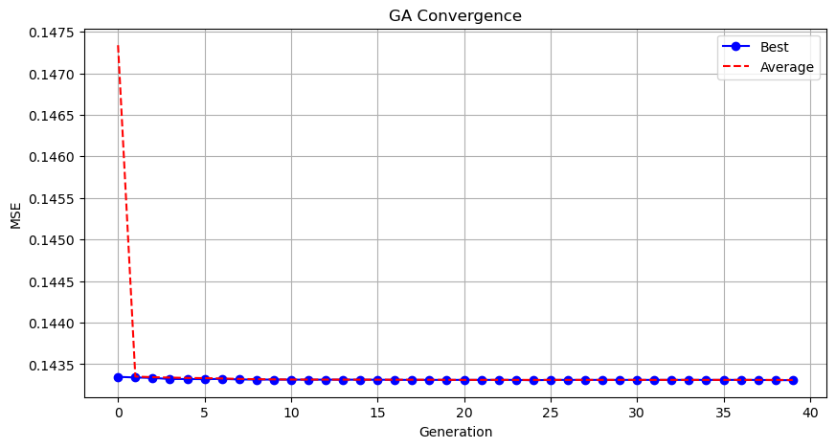

Genetic Algorithm completed successfully with MSE: 0.1433

==================================================

Running Particle Swarm Optimization...

==================================================

==================================================

=== PARTICLE SWARM OPTIMIZATION ===

==================================================

[Initialization]

- Swarm size: 60 particles

- Iterations: 40

- Cognitive weight: 0.5

- Social weight: 0.5

- Inertia weight: 0.5

- Search space: 63 features

- Target: Minimize MSE using XGBoost

[Optimization Progress]

No constraints given.

Iteration 1: Best MSE = 0.245580

Best after iteration 1: [5.97570019e-01 8.00492480e-01 3.10137595e-01 6.52748113e-01

1.29643596e-01 2.30131999e-01 7.76671375e-01 9.41294592e-01

4.39928326e-04 8.19419504e-01 6.40753874e-02 4.43858601e-02

2.17132635e-01 2.57799136e-01 9.34342228e-01 5.93801392e-01

7.12468213e-01 4.03644693e-01 4.96665145e-01 1.96354359e-01

9.61056313e-01 1.73820387e-01 3.16665307e-01 4.68985839e-01

7.58198821e-01 7.19096307e-01 5.07507705e-01 4.74953638e-01

7.92178052e-01 4.73664068e-01 8.91964720e-01 3.24878821e-01

7.97079294e-01 9.24122798e-01 7.29080139e-01 1.73637846e-02

7.45458832e-01 4.86224359e-01 4.04790919e-01 2.94608595e-01

8.58068634e-01 3.62870071e-01 3.62394695e-01 6.90090225e-01

5.88105587e-01 2.64376195e-01 7.37796595e-01 1.35768018e-01

6.64611656e-01 6.98663696e-01 4.71386997e-01 5.27569698e-01

9.31219202e-01 5.09924695e-02 2.10543021e-01 2.19876931e-01

2.83021430e-01 9.07166624e-01 4.61526697e-01 4.04435238e-01

2.18865992e-01 8.99219934e-01 6.26875081e-01] 0.14334192872047424

New best for swarm at iteration 2: [1. 0.95067097 0.0759594 0.92307783 0.67567896 0.07734935

1. 0.77277759 0.16221043 0.55279957 0.88049426 0.23886555

0.22785928 0.00408469 0.35905972 0.9376708 0.88062127 0.07319959

0.57693445 0.87919369 0.78557385 0.86323833 0.40810704 0.33394051

0.77733013 0.24481496 0.30399188 0.40886286 0.06779801 0.77545255

0.97802898 0.11443981 0.33009509 0.4212375 0.5644426 0.60218504

0.41639487 0.74404933 0.26550195 0.4034238 1. 0.00749541

0.73736675 0.62863129 1. 0.90762131 1. 0.23470348

0.35765071 0.83368156 0.1545145 0.68494571 0.30188576 0.49933167

1. 0.23106478 0.19127485 0.8420049 0.68303486 0.

1. 0.24954093 0.18825142] 0.14333966374397278

Stopping search: Swarm best objective change less than 0.0001

==================================================

=== OPTIMIZATION RESULTS ===

==================================================

▶ Best MSE achieved: 0.143340

▶ Time elapsed: 107.41 seconds

▶ Features selected: 32/63 (49.2% reduction)

▶ Selected features (with weights):

1. CreditScore (weight: 1.000)

2. AnnualIncome (weight: 0.951)

3. LoanDuration (weight: 0.923)

4. Age (weight: 0.676)

5. MonthlyDebtPayments (weight: 1.000)

6. CreditCardUtilizationRate (weight: 0.773)

7. NumberOfCreditInquiries (weight: 0.553)

8. DebtToIncomeRatio (weight: 0.880)

9. SavingsAccountBalance (weight: 0.938)

10. CheckingAccountBalance (weight: 0.881)

11. RetirementAccountBalance (weight: 0.577)

12. EmergencyFundBalance (weight: 0.879)

13. TotalAssets (weight: 0.786)

14. TotalLiabilities (weight: 0.863)

15. MortgageBalance (weight: 0.777)

16. UtilityBillsPaymentHistory (weight: 0.775)

17. OtherInsurancePolicies (weight: 0.978)

18. AnnualExpenses (weight: 0.564)

19. MonthlyHousingCosts (weight: 0.602)

20. MonthlyFoodCosts (weight: 0.744)

21. EmploymentStatus_1 (weight: 1.000)

22. MaritalStatus_1 (weight: 0.737)

23. MaritalStatus_2 (weight: 0.629)

24. MaritalStatus_3 (weight: 1.000)

25. EducationLevel_1 (weight: 0.908)

26. EducationLevel_2 (weight: 1.000)

27. HomeOwnershipStatus_1 (weight: 0.834)

28. HomeOwnershipStatus_3 (weight: 0.685)

29. LoanPurpose_3 (weight: 1.000)

30. LifeInsuranceStatus_Uninsured (weight: 0.842)

31. CarInsuranceStatus_Uninsured (weight: 0.683)

32. EmployerType_1 (weight: 1.000)

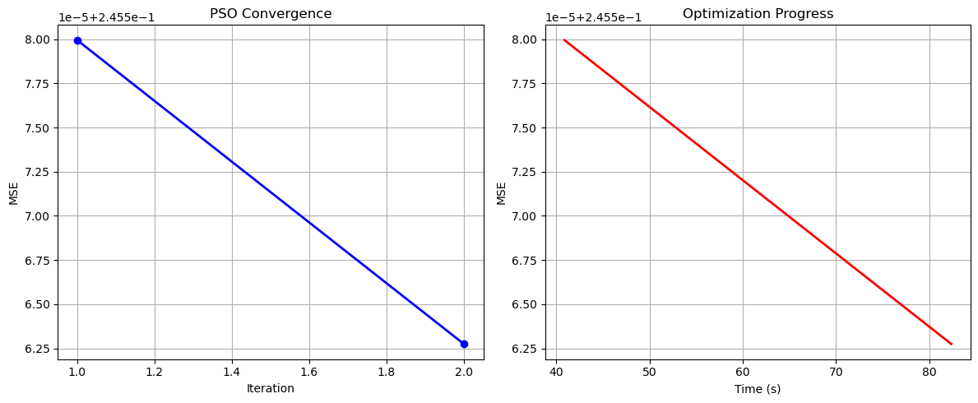

Particle Swarm Optimization completed successfully with MSE: 0.1433

==================================================

Running Whale Optimization...

==================================================

==================================================

=== WHALE OPTIMIZATION ALGORITHM ===

==================================================

[Initialization]

- Population: 60 whales

- Max iterations: 40

- Spiral coefficient (b): 1.0

- Search space: 63 features

- Target: Minimize MSE using XGBoost

[Optimization Progress]

Iter 40/40 | Best MSE: 0.143327

==================================================

=== OPTIMIZATION RESULTS ===

==================================================

▶ Best MSE achieved: 0.143327

▶ Time elapsed: 1678.62 seconds

▶ Features selected: 28/63 (55.6% reduction)

▶ Selected features:

1. CreditScore

2. AnnualIncome

3. LoanDuration

4. NumberOfDependents

5. NumberOfCreditInquiries

6. DebtToIncomeRatio

7. BankruptcyHistory

8. PreviousLoanDefaults

9. PaymentHistory

10. SavingsAccountBalance

11. TotalLiabilities

12. RentPayments

13. AutoLoanBalance

14. PersonalLoanBalance

15. OtherInsurancePolicies

16. AnnualBonuses

17. AnnualExpenses

18. MonthlyHousingCosts

19. MonthlyTransportationCosts

20. MonthlyFoodCosts

21. MonthlyHealthcareCosts

22. EmploymentStatus_2

23. MaritalStatus_1

24. EducationLevel_2

25. HomeOwnershipStatus_3

26. LoanPurpose_2

27. LoanPurpose_3

28. HomeInsuranceStatus_Uninsured

▶ Convergence progress:

- Initial MSE: 0.2500

- Final MSE: 0.1433

- Improvement: 42.7%

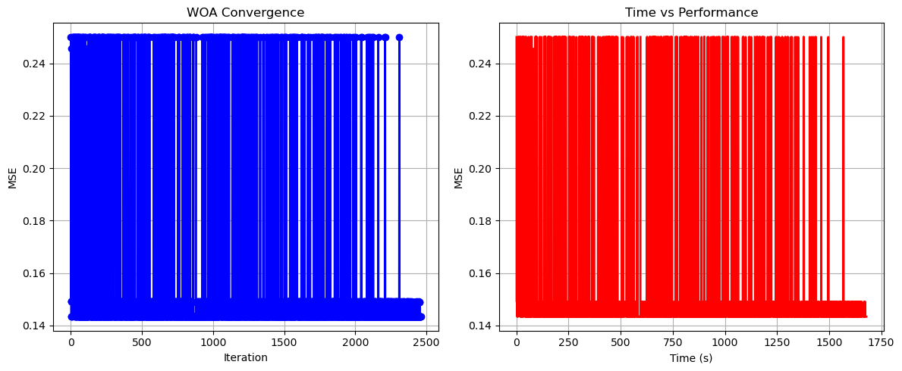

Whale Optimization completed successfully with MSE: 0.1433

==================================================

Running Squid Game Optimizer...

==================================================

==================================================

=== SQUID GAME OPTIMIZER (SGO) ===

==================================================

[Initialization]

- Players: 60 (30 offensive, 30 defensive)

- Max games: 40

- Search space: 63 features

- Target: Minimize MSE using XGBoost

==================================================

=== OPTIMIZATION RESULTS ===

==================================================

▶ Best MSE achieved: 0.143316

▶ Time elapsed: 1651.88 seconds

▶ Features selected: 25/63 (60.3% reduction)

▶ Selected features:

1. CreditScore

2. AnnualIncome

3. PaymentHistory

4. SavingsAccountBalance

5. RetirementAccountBalance

6. EmergencyFundBalance

7. TotalLiabilities

8. MortgageBalance

9. RentPayments

10. PersonalLoanBalance

11. StudentLoanBalance

12. UtilityBillsPaymentHistory

13. OtherInsurancePolicies

14. JobTenure

15. AnnualBonuses

16. MonthlyTransportationCosts

17. MonthlyFoodCosts

18. EmploymentStatus_2

19. MaritalStatus_2

20. MaritalStatus_3

21. HomeOwnershipStatus_3

22. HealthInsuranceStatus_Uninsured

23. CarInsuranceStatus_Uninsured

24. EmployerType_1

25. EmployerType_2

▶ Convergence progress:

- Initial MSE: 0.1433

- Final MSE: 0.1433

- Improvement: 0.0%

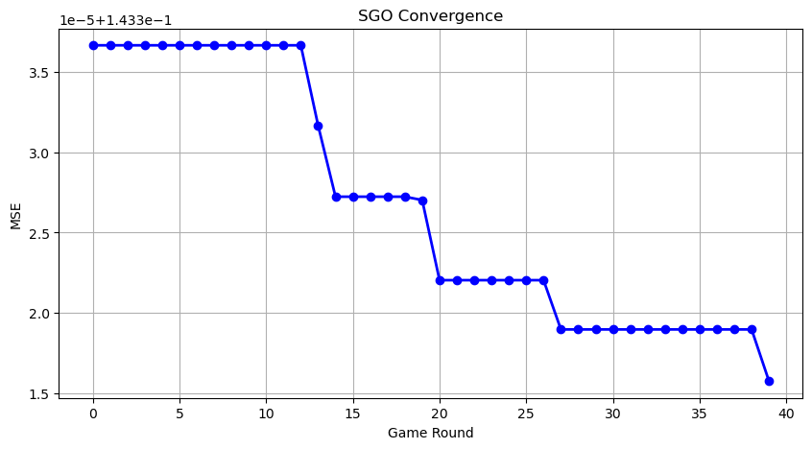

Squid Game Optimizer completed successfully with MSE: 0.1433

==================================================

Running PSH-Hyptrite...

==================================================

==================================================

=== PSH-HYPTRITE OPTIMIZATION ===

==================================================

[Initialization]

- Search points: 60

- Max iterations: 40

- Initial radius: 0.5 (adaptive)

- Hypersphere samples: 3 per point

- Search space: 63 features

- Target: Minimize MSE using XGBoost

[Optimization Progress]

Iter 40/40 | Best MSE: 0.143311 | Radius: 0.0125

==================================================

=== OPTIMIZATION RESULTS ===

==================================================

▶ Best MSE achieved: 0.143311

▶ Time elapsed: 5746.67 seconds

▶ Features selected: 31/63 (50.8% reduction)

▶ Selected features (with weights):

1. CreditScore (weight: 0.663)

2. AnnualIncome (weight: 0.664)

3. Age (weight: 0.689)

4. CreditCardUtilizationRate (weight: 0.930)

5. NumberOfOpenCreditLines (weight: 0.543)

6. NumberOfCreditInquiries (weight: 0.710)

7. DebtToIncomeRatio (weight: 0.796)

8. BankruptcyHistory (weight: 0.722)

9. SavingsAccountBalance (weight: 0.551)

10. CheckingAccountBalance (weight: 0.954)

11. RetirementAccountBalance (weight: 0.514)

12. EmergencyFundBalance (weight: 0.745)

13. PersonalLoanBalance (weight: 0.829)

14. OtherInsurancePolicies (weight: 0.549)

15. MonthlySavings (weight: 0.680)

16. AnnualExpenses (weight: 0.506)

17. MonthlyHousingCosts (weight: 0.700)

18. MonthlyTransportationCosts (weight: 1.000)

19. MonthlyFoodCosts (weight: 0.522)

20. MonthlyHealthcareCosts (weight: 0.573)

21. EmploymentStatus_2 (weight: 0.844)

22. MaritalStatus_1 (weight: 1.000)

23. MaritalStatus_3 (weight: 0.860)

24. EducationLevel_3 (weight: 0.503)

25. HomeOwnershipStatus_2 (weight: 0.767)

26. HomeOwnershipStatus_3 (weight: 0.661)

27. LoanPurpose_3 (weight: 0.636)

28. LoanPurpose_4 (weight: 0.934)

29. LifeInsuranceStatus_Uninsured (weight: 0.963)

30. EmployerType_2 (weight: 0.817)

31. EmployerType_3 (weight: 0.931)

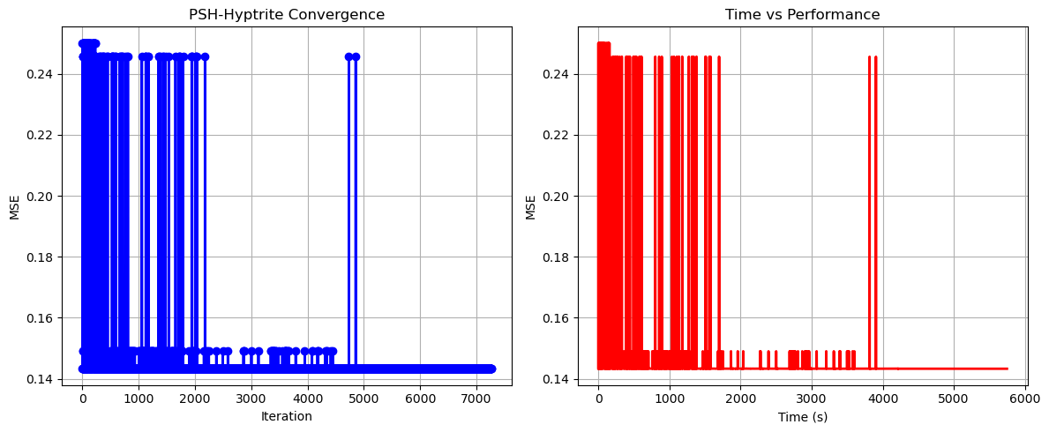

PSH-Hyptrite completed successfully with MSE: 0.1433

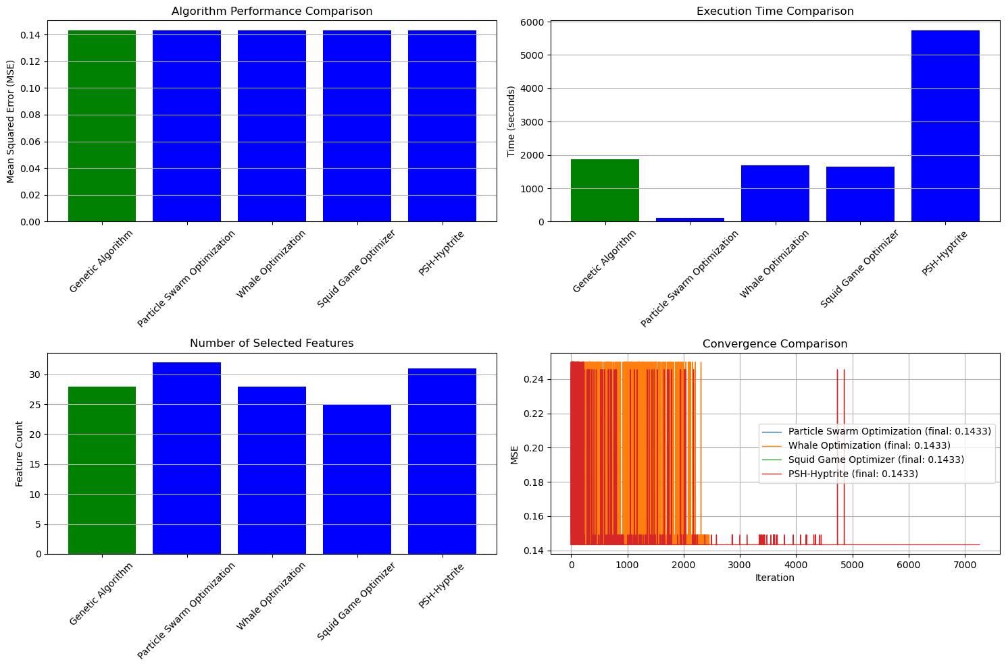

==================================================

FINAL RESULTS SUMMARY

==================================================

🏆 Best Algorithm: Genetic Algorithm

📉 Best MSE Achieved: 0.143307

⏱️ Execution Time: 1862.79 seconds

🔢 Features Selected: 28

Selected Features:

1. CreditScore

2. AnnualIncome

3. Age

4. NumberOfDependents

5. NumberOfCreditInquiries

6. DebtToIncomeRatio

7. BankruptcyHistory

8. CheckingAccountBalance

9. RetirementAccountBalance

10. EmergencyFundBalance

11. LengthOfCreditHistory

12. AutoLoanBalance

13. StudentLoanBalance

14. OtherInsurancePolicies

15. JobTenure

16. AnnualExpenses

17. MonthlyHousingCosts

18. MonthlyFoodCosts

19. MonthlyHealthcareCosts

20. EmploymentStatus_2

21. EducationLevel_1

22. EducationLevel_4

23. HomeOwnershipStatus_1

24. HomeOwnershipStatus_3

25. CarInsuranceStatus_Uninsured

26. HomeInsuranceStatus_Uninsured

27. EmployerType_1

28. EmployerType_2